**JNN Template**

**Polarity Reversion of the Operation Mode of HfO2-Based Resistive Random Access Memory Devices by Inserting Hf Metal Layer**

Ching-Shiang Peng,a,z Wen-Yuan Chang,b,z Ming-Ho Lin,a Wei-Su Chen,c

Frederick Chen,c and Ming-Jinn Tsaic,*

*aDepartment of Materials Science and Engineering, National Tsing-Hua University, Hsinchu 300, Taiwan*

*bInstitute of Photonics and Optoelectronics, National Taiwan University, Taipei 106, Taiwan*

*cElectronics and Optoelectronics Research Laboratory, Industrial Technology Research Institute, Chutung,*

*Hsinchu 310, Taiwan*

*\*Corresponding author* Name**: ………………………**Email:**…………………………**

**Insert Submission Date Here**

Submitted/Received: ……....……………..… Accepted: …………....…………...

**Abstract**

The reversion of polarity within bipolar resistive switching operation occurs in Pt/HfO2/TiN and Pt/Hf/HfO2/TiN resistive random access memory devices. This reversion of voltage polarity is the result of interface generation which induces a conduction mechanism transformation from Poole-Frenkel emission to space charge limited current mechanism. To prove the reversion of polarity, this study uses curve fitting of I-V relations to verify the conduction mechanism theoretically and physical analysis to verify the oxygen ion distribution practically. The proposed Pt/Hf/HfO2/TiN devices exhibit good resistive switching characteristics, such as good uniformity, low voltage operation, robust endurance (103 dc sweep), and long retention (3×104 s at 85 oC).

**\*\*First Time Use of Abbreviations:** No abbreviations are allowed in the title and abstract, therefore, all abbreviations should be defined the first time they are used within the title and text. For example, use first time as; Fourier transform infrared (FTIR) spectroscopy, scanning electron microscopy (SEM), transmission electron microscope (TEM), X-ray diffraction (XRD), X-ray photoelectron spectroscopy (XPS), Visible/near-infrared (Vis/NIR) spectroscopy, X‐ray absorption fine structure (EXAFS) spectroscopy, etc.

**Keywords:** HfO2, Resistive random access memory, Hf Metal Layer, polarity reversal

**1. Introduction**

Resistive random access memory (RRAM) is an ideal candidate for non-volatile memory applications because of its simple structure, great scalability, fast switching speed, low power consumption, and compatibility with complementary metal-oxide semiconductor technology [1,2]. RRAM devices achieve the memory effect using the switchable resistance transformation between a high resistance state (HRS) and a low resistance state (LRS), and typically consist of a metal/insulator/metal structure. RRAM devices generally have two switching modes (unipolar and bipolar), which alternate based on the operating voltage polarity. Unipolar resistive switching occurs in any single voltage bias and does not depend on voltage polarity. Conversely, bipolar resistive switching depends on the variation of voltage polarity to complete the set (i.e., from the HRS to the LRS) and reset (i.e., from the LRS to the HRS) processes. Recent developments in RRAM have shifted to bipolar RRAM for several advantages, including a stable ON/OFF ratio, robust endurance, good retention, smaller switching voltage fluctuation, and the one selector-one resistor (1S1R) application [3].

The transition metal oxide, HfO2, is already widely used in semiconductor industries because of its superior physical properties, such as large permittivity, subsequent band gap, and excellent thermal stability [4]. In addition to its use as high-k/metal gate stacks, HfO2-based RRAM has attracted significant attention for its potential in next-generation nonvolatile memory. HfO2-based RRAM devices are formed by an electric-field induced conductive filaments formation/rupture process, and possess superior bipolar resistive switching for future RRAM applications.

**2. Experimental Details**

In this study, RRAM devices consist of Pt/HfO2/TiN and Pt/Hf/HfO2/TiN structures. HfO2 thin films were deposited on TiN (50 nm)/Ti (150 nm)/SiO2 (200 nm)/p-Si substrates at 200 oC using the atomic layer deposition (ALD) method. The HfO2 thin film (derived from TEMAH and H2O precursors) was controlled at approximately 10 nm, and the deposition thickness of HfO2 per ALD cycle was approximately 0.1 nm. After HfO2 thin-film deposition, Hf and Pt metal layers measuring 40 nm and 70 nm in thickness were capped continuously by dc sputtering and patterned by a shadow mask with a diameter of 200 μm. The Pt capping layer prevents oxygen penetration from the atmosphere.

The Pt/Hf/HfO2/TiN device was subjected to post metal annealing (PMA) at 400 oC for 30 s in a N2 atmosphere. For a comparison, a reference sample made without Hf layer and PMA process was also prepared, denoted as Pt/HfO2/TiN device. The chemical-bonding states of Hf atoms in thin films were analyzed using the X-ray photoelectron emission spectrum (XPS). The electrical properties of the devices were measured using a Keithley 4200 semiconductor parameter analyzer. During the voltage-sweeping mode measurement, the bias was defined as positive when the current flowed from the top electrode to the bottom electrode, and was defined as negative when the current flowed in the opposite direction.

**3. Results and Discussion**

Figures 1a and 1b show the reverse polarity operation within bipolar resistive switching. Figure 1a shows that the set operation by a negative bias and the reset operation by a positive bias appear in the electrical characteristics of Pt/HfO2/TiN RRAM devices. The same polarity was observed in similar devices described in previous researches.13,14 After the Hf metal layer deposition and PMA processes, Pt/Hf/HfO2/TiN RRAM devices show reverse polarity operation (i.e., the set operation by a positive bias, and the reset operation by a negative bias) in a stable resistive switching situation, as shown in Fig. 1b. The experimental results and literatures review in this study will confirm that the reverse polarity is correlated with interface-producing and conduction mechanism, transforming between two structures. In Pt/HfO2/TiN RRAM devices, the conduction mechanism in pure HfO2 thin films is usually attributed to the Poole-Frenkel emission.15,16 The Poole-Frenkel emission equation can be expressed as $J=\left(qN_{c}μ\right)Eexp 〔-\frac{qΦt}{kT}+\frac{q\sqrt{qE/πε_{γ}ε_{0}}}{rkT} 〕$, in which *q* is the electronic charge, $N_{c}$ is the density of states in the conduction band, *μ* is the electronic drift mobility, *q*Φt is the trap level below the conduction band, *εγ* is the dynamic dielectric constant, *εo* is the permittivity of free space, *k* is Boltzmann’s constant, *T* is the temperature, and *r* is a coefficient ranging between 1 and 2.17,18 If r = 2, the conduction mechanism is so-called the normal Poole-Frenkel emission. However, when the insulator contains another influential trap, r is equal to 1 and the conduction is called the modified Poole-Frenkel emission. In the reset process, the $㏑\left(J/E\right)- \sqrt{E}$ relationship of the HRS in the high electric field exhibits linear dependence, as shown in Fig. 2a. Accordingly, a refractive index of n = 2.05 can be obtained from the slope of the Poole-Frenkel plot at r = 1. This value is close to that of HfO2 thin films reported in previous studies.19,20 The consistency between these results and fitting data implies that Poole-Frenkel emission is the primary conduction

**4. Conclusion**

In conclusion, this study shows that inserting a Hf metal layer into a Pt/HfO2/TiN device and subjecting it to a PMA process creates a Pt/Hf/HfO2/TiN device that exhibits polarity reversion in the resistive switching property. Inserting a Hf metal layer and performing the PMA process activated the Hf metal layer as an oxygen storage layer, which makes redox fixed near the interface between the Hf metal and the HfO2 thin film. Consequently, the interface generation (HfOx) that makes the conduction mechanism switch to SCLC mechanism from Poole-Frenkel emission, leading to a polarity reversion. The proposed Pt/Hf/HfO2/TiN devices also exhibited good resistive switching characteristics and switching uniformity, with a low-voltage operation, 103 dc sweep endurance, and 3×104 s retention test at 85 oC.

**Acknowledgments**

The authors would like to express heartfelt thanks to the Prof. S.-J. Lin and the late Prof. T.-B. Wu from National Tsing-Hua University. C.-S. Peng is grateful to Dr. D.-T. Lee and G.H. Group for their helpful discussions.

**Follow JNN Reference** **EXAMPLE;**

**References and Notes**

Please use **HARVARD Referencing Style** from **Google Scholar** (<https://scholar.google.com>). All references should be listed in a proper Harvard style on a separate page, numbered in the sequence in which they occur in the text. Cite references numerically in a bracket [ x ] in the text and follow the same numerical order in the “Reference List” at the end of the manuscript. Do not use the phrases "et al." or "ibid." in the reference list, instead, include names of all authors in a reference.

Authors could directly copy references in a Harvard style from the Google Scholar (https://scholar.google.com) and then paste in the Reference List of the manuscript as such.

EXAMPLES

**1. Journal Articles**

1. Xu, Y., Bai, H., Lu, G., Li, C. and Shi, G., **2008.** Flexible graphene films via the filtration of water-soluble noncovalent functionalized graphene sheets. *Journal of the American Chemical* *Society*, *130*(18), pp.5856-5857.

2. Kim, K.S., Kim, K.H., Nam, Y., Jeon, J., Yim, S., Singh, E., Lee, J.Y., Lee, S.J., Jung, Y.S., Yeom, G.Y. and Kim, D.W., **2017**. Atomic layer etching mechanism of MoS2 for nanodevices. *ACS* *Applied Materials & Interfaces*, *9*(13), pp.11967-11976.

**2. Book**

3. Nalwa, H.S. and Miyata, S., eds., **1996.** *Nonlinear Optics of Organic Molecules and Polymers*. Boca Raton, CRC Press.

**3. Book Chapter**

4. Krill, C.E., Harberkorn, R. and Birringer, R., **1999**. in *Handbook of Nanostructured Materials and Nanotechnology*, edited by H. S. Nalwa, Academic Press, Vol. 2, pp.155-211.

**4. Website**

5. National Renewable Energy Laboratory (NREL) (<https://www.nrel.gov/solar>)

**5. Conference Proceedings**

6. Kimura, J. and Shibasaki, H., eds., **(1995)**. Recent Advances in Clinical Neurophysiology. *Proceedings of the 10th International Congress of EMG and Clinical Neurophysiology*, October 15-19; Kyoto, Japan. pp.10-15.

Table I.Classified conditions for sample identifications of various ARC layers on microtextured surface.

|  |  |  |  |
| --- | --- | --- | --- |
| Sample | SiNx (nm)  (bottom) | SiO2 (nm)  (middle) | SiNx (nm)  (top) |
| RL | 90 | - | - |
| BL1 | 5 | 20 | 60 |
| BL2 | 15 | 20 | 60 |
| BL3 | 25 | 20 | 60 |
| TL1 | 60 | 20 | 5 |
| TL2 | 60 | 20 | 15 |
| TL3 | 60 | 20 | 25 |

Table II. Average PR and the absorption peak of the samples in the spectral wavelength region of 300~1,100 nm.

`

|  |  |  |  |  |  |  |  |
| --- | --- | --- | --- | --- | --- | --- | --- |
| Sample | RL | BL1 | BL2 | BL3 | TL1 | TL2 | TL3 |
| Average PR (%) | 4.52 | 6.91 | 6.96 | 6.95 | 3.55 | 2.97 | 3.16 |
| Absorption peak (nm) | 516 | 854 | 852 | 852 | 682 | 760 | 854 |

**ALL FIGURES IN VERY HIGH QUALITY REQUIRED**

**Important Note** – Poor/blurred quality figures will not be accepted at all. There are

*no charges* for color figures whatsoever so please make all figures in COLORS for a better

presentation. It is very important to use **Large Fonts (size) for Numbering and Ligands** in

all figures as shown below.

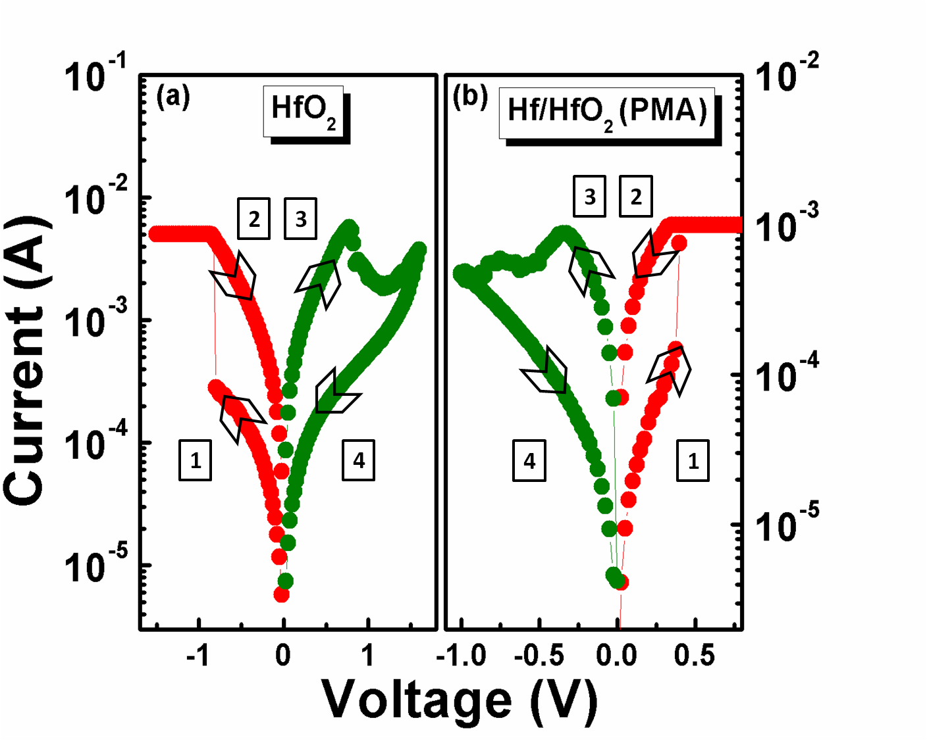

**Figure 1**. Reverse polarity operation in resistive switching between Pt/HfO2/TiN and Pt/Hf/HfO2/TiN devices.

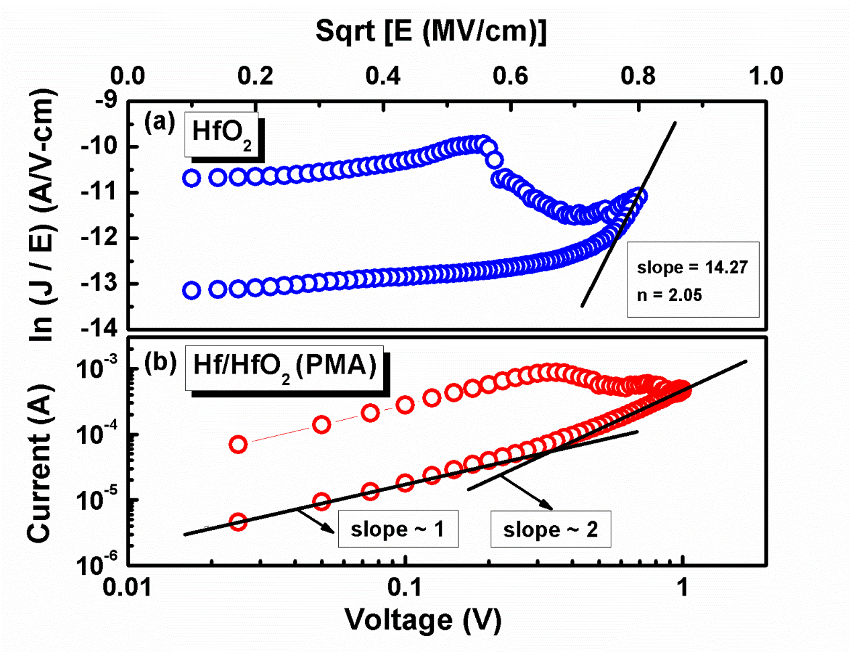

**Figure 2**. Curve fitting in Pt/HfO2/TiN devices (a) Poole-Frenkel emission and in

Pt/Hf/HfO2/TiN devices (b) SCLC mechanism.

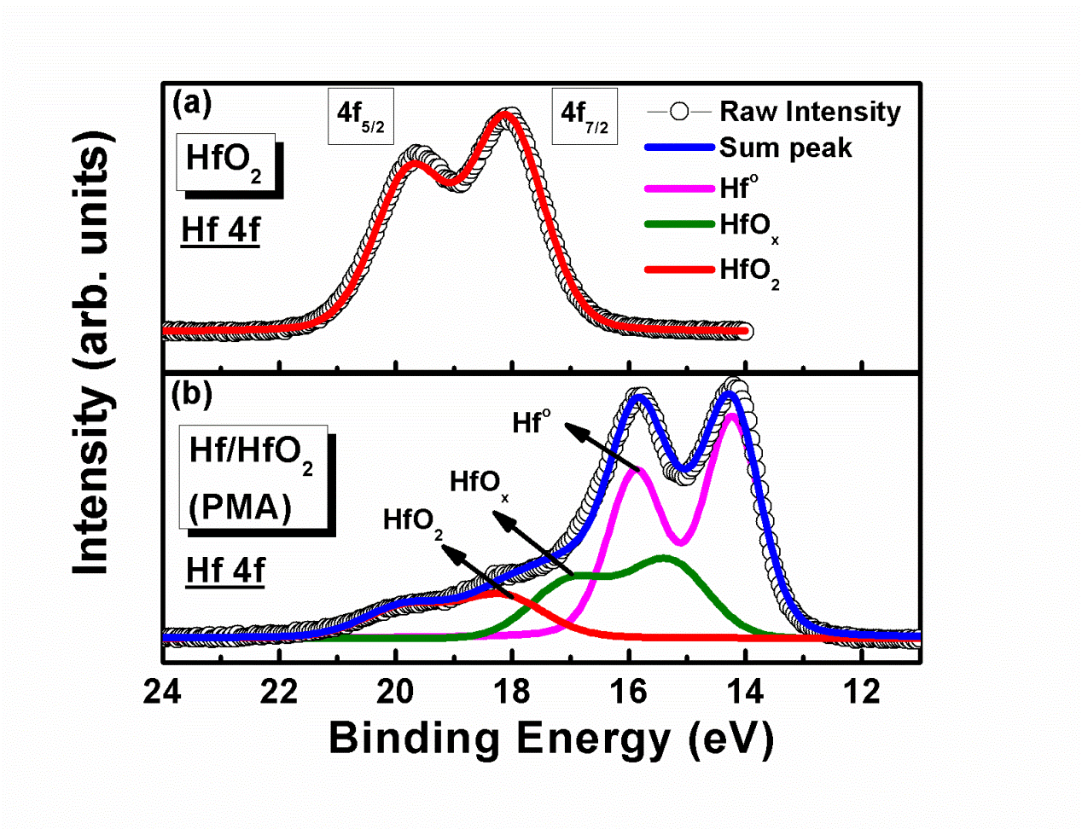

**Figure 3.** XPS spectra of Hf 4f core levels: (a) the HfO2 thin film. (b) Interface between Hf/HfO2.

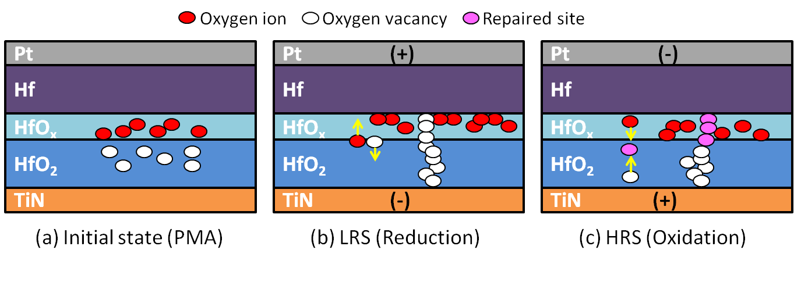

9

**Figure 4**. Possible scenarios of switching mechanisms for the Pt/Hf/HfO2/TiN device with positive-bias or negative-bias voltage.  
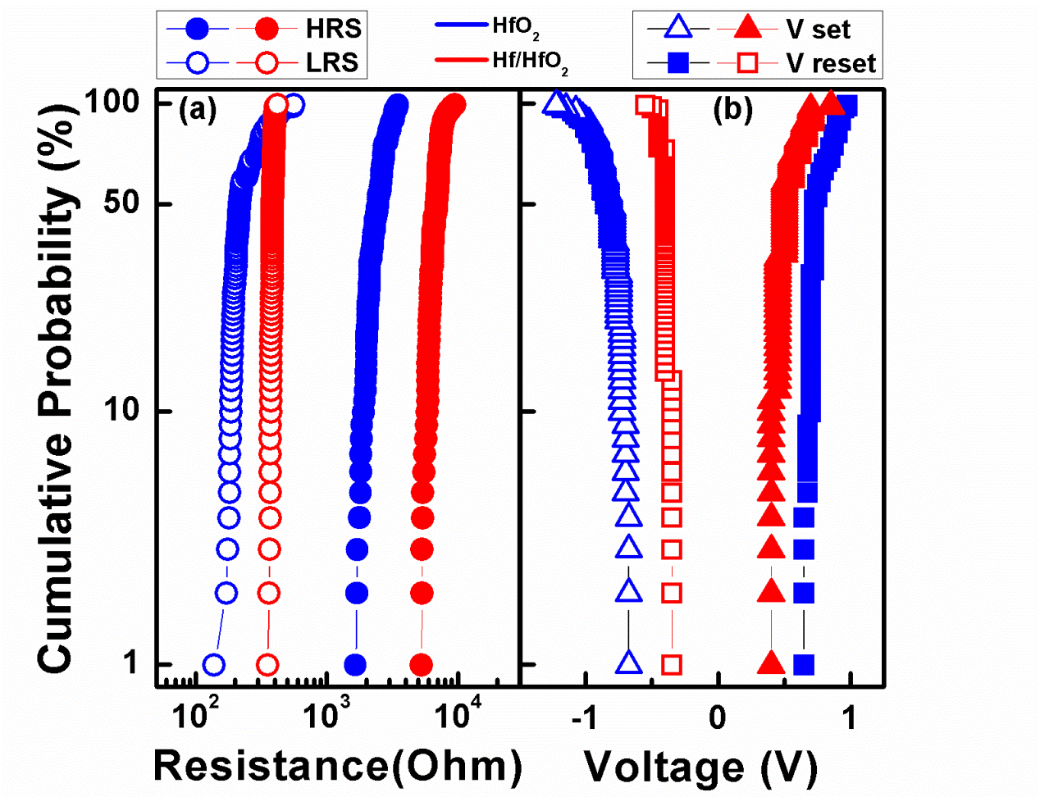

**Figure 5.** Statistical distribution of resistive switching parameters during 100 continuous cycles in both Pt/HfO2/TiN and Pt/Hf/HfO2/TiN devices. (a) HRS and LRS. (b) Vset and Vreset.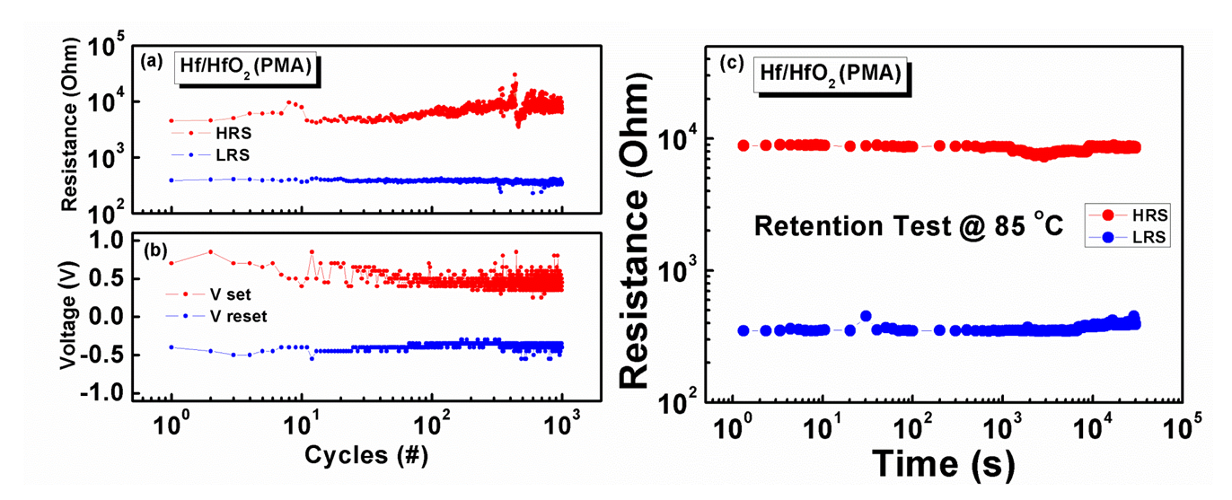

**Figure 6.** The 103 stable endurance cycles of the Pt/Hf/HfO2/TiN device: (a) HRS and LRS. (b)Vset and Vreset . (c) Data retention characteristics at 85 oC under 100mV stress.

**GRAPHICAL ABSTRACT**

The reversion of polarity within bipolar resistive switching operation occurs in Pt/HfO2/TiN and Pt/Hf/HfO2/TiN resistive random access memory devices. The proposed Pt/Hf/HfO2/TiN devices exhibit good resistive switching characteristics, such as good uniformity, low voltage operation, robust endurance (103 dc sweep), and long retention (3×104 s at 85 oC).

